# Create a bash script task

1. Create on Bash script to check if a directory is available or not.

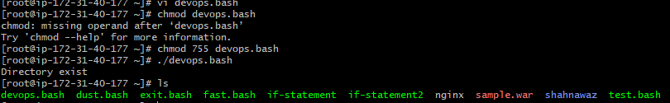

1. Create a bash script which will create multiple files.

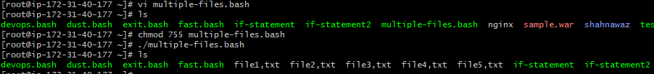

1. Create a bash script to take backup of a directory.

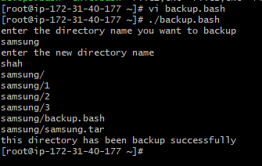

1. Create a bash script to install Nginx in ec2 server.

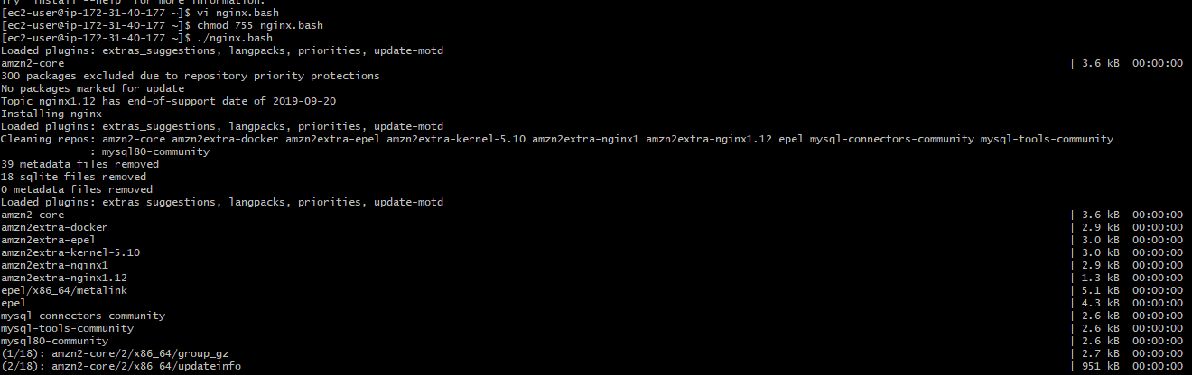 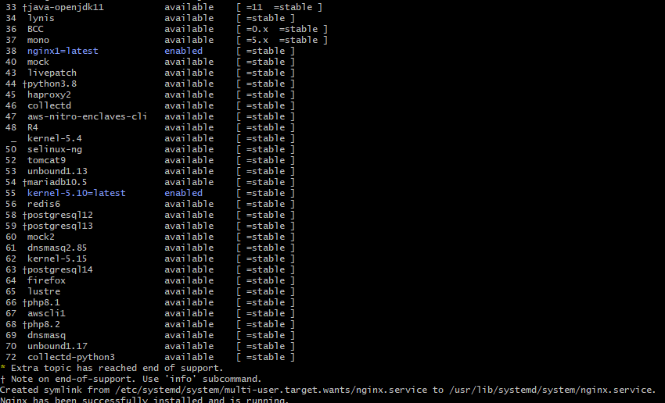

1. Create a bash script to install Apache Tomcat in ec2 server.
2. Create a bash script to check list if Nginx service is running or not, if not running then script should start the service.

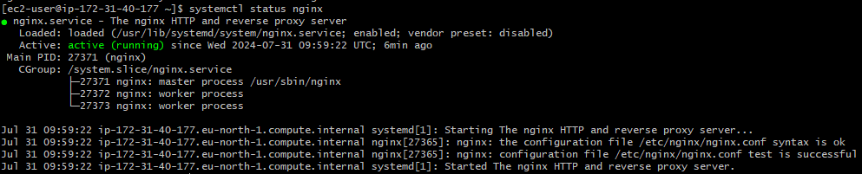

1. Create a bash script for calculator.

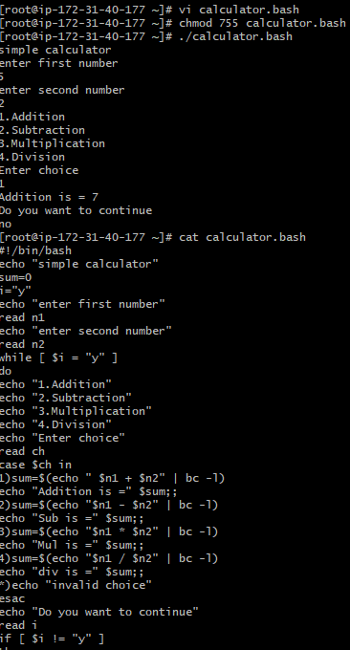

1. Create a bash script to check if directory is available or not, if not then create a directory.

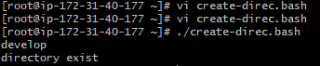

1. Create bash script to delete last 3 lines for a file.

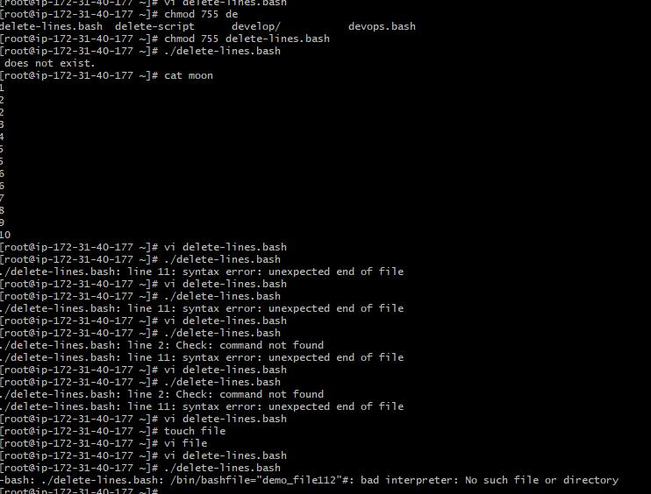

Exercise Crontab Entries

